**IFT 458/598: Middleware Prog & Database Security (Fall 2022)**

Saurabh Verma

Module 2 Assignment JavaScript language

Instructor: Dinesh Sthapit

September 10, 2022

**Module 2 Assignment JavaScript language**

**Steps performed while implementing this assignment:**

Introduction to JavaScript -1

Step 1: Created a function to greet students:

JavaScript Function Refactoring 2

Step 2: Used anonymous function and fat arrow function:

JavaScript Refactoring 3

Step 3: Printed out the full name of the student using fat arrow function in the format lastName, firstName. middleName:

JavaScript Variables 4

Step 4: Used different variables and found its data types by ‘typeof’ function:

JavaScript Objects 5

Step 5: Used greet object to display greetings with respect to age of student:

JavaScript Parameter (Function as a parameter) 6

Step 6: Passing function as a parameter inside another function:

JavaScript Master Document Reference (required) 7

Step 7: Read the information provided on JavaScript MDN web docs page.

JavaScript Objects II 8

Step 8: Learnt about array objects and how to use particular elements of arrays:

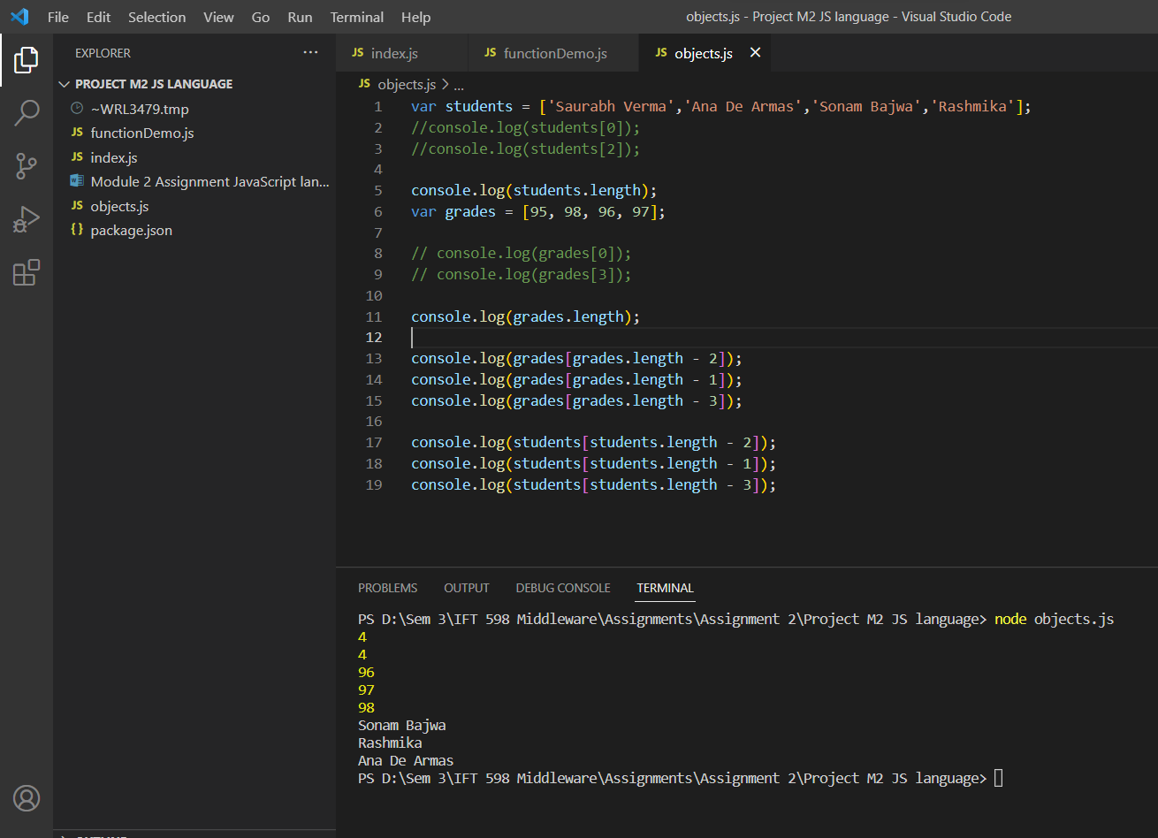

JavaScripts Arrays 9

Step 9: Learned about objects and their properties, also how to use functions in objects for calculations:

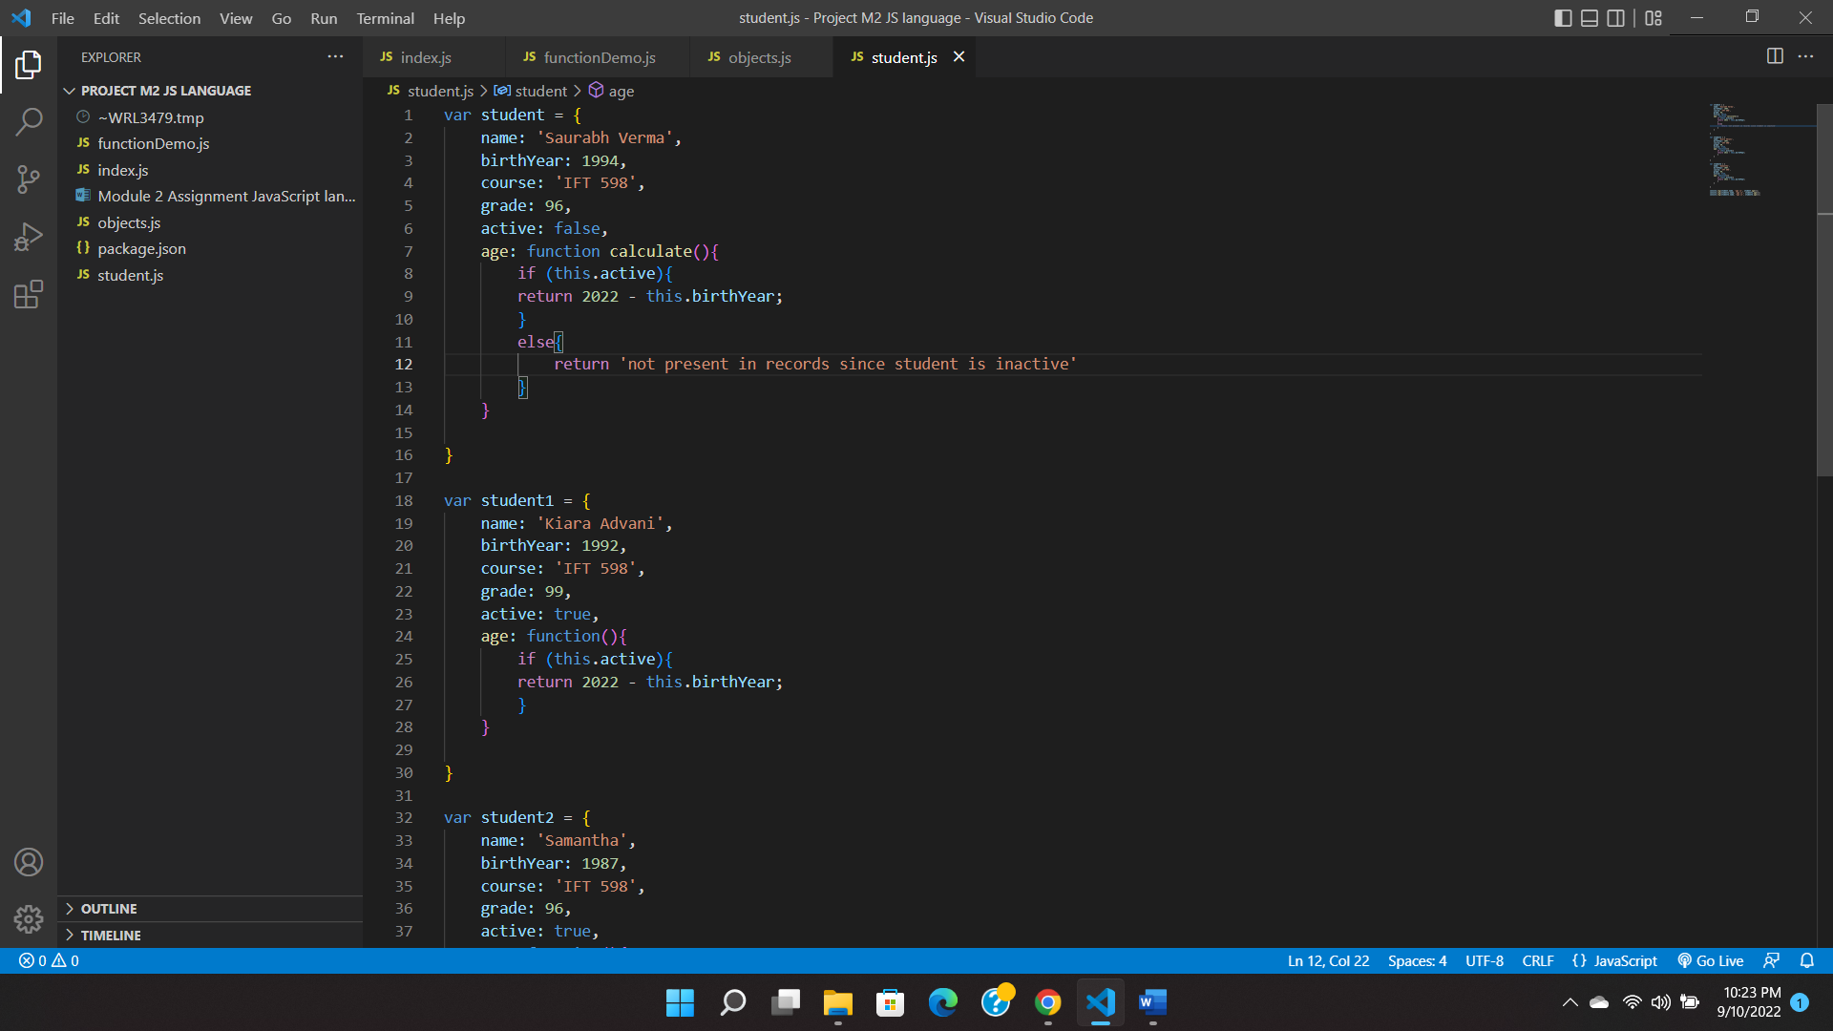

Accessing Elements of JavaScript Object Arrays 10

Step 10: Pushed objects as elements in an empty array and applied foreach loop to access a function present in the objects:

**References**

JavaScript MDN web docs: <https://developer.mozilla.org/en-US/docs/Web/JavaScript>

GitHub repository: